Oct 24, 2021
*. 07:00 Ночные работы по задаче "обновить прошивку на сервере" (https://jira.tcsbank.ru/browse/IN-1674) [Третьяков Артём].
Возникли проблемы при загрузке ОС. В опциях старта ОС в grub2 было указано смонтировать не существующий swap раздел. При попытке смонтировать его загрузка обрывалась с попаданием в консоль dracut. Смонтировал загрузочный раздел /boot в /mnt/boot, убрал опцию монтирования swap. Сервер загрузился.
Перед этим проверил на ошибки раздел /root и создал swap-файл в нём.

I updated firmware as I did it before (here are my detail notes 20200415 Mellanox network card spam messages on server console.docx).
Then I sent server to reboot. And during boot process I seen follow messages.
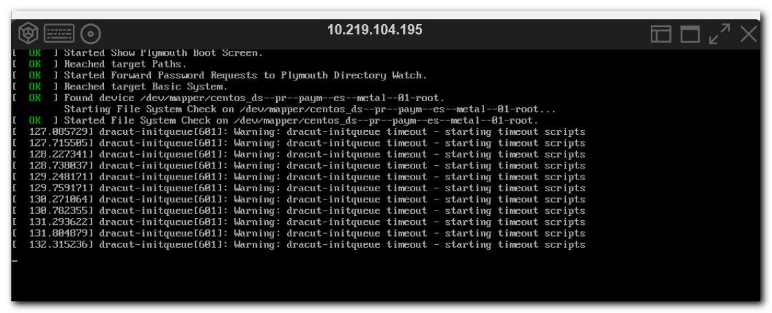
There were lot of similar messages. And at the end I received dracut prompt.
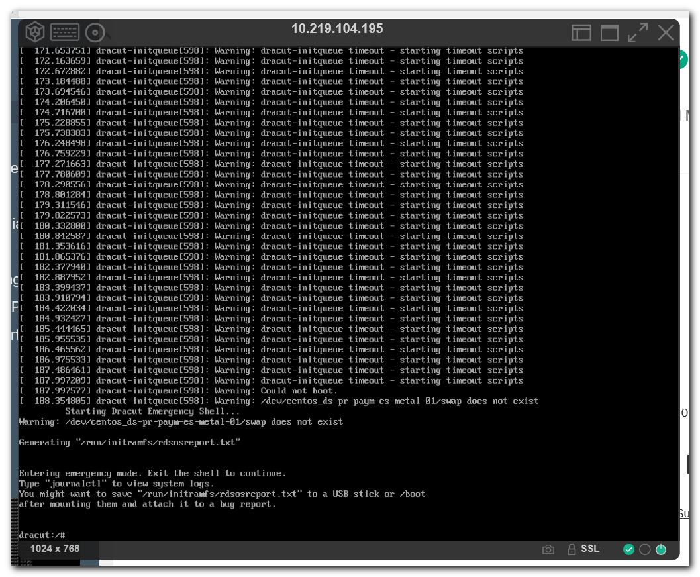

# I found this article with advices how to help myself under dracut environment during boot problems.
# https://fedoraproject.org/wiki/How_to_debug_Dracut_problems

# I decided to mount /root partition, that was under LVM.
lvm vgscan
lvm vgchange -ay
blkid
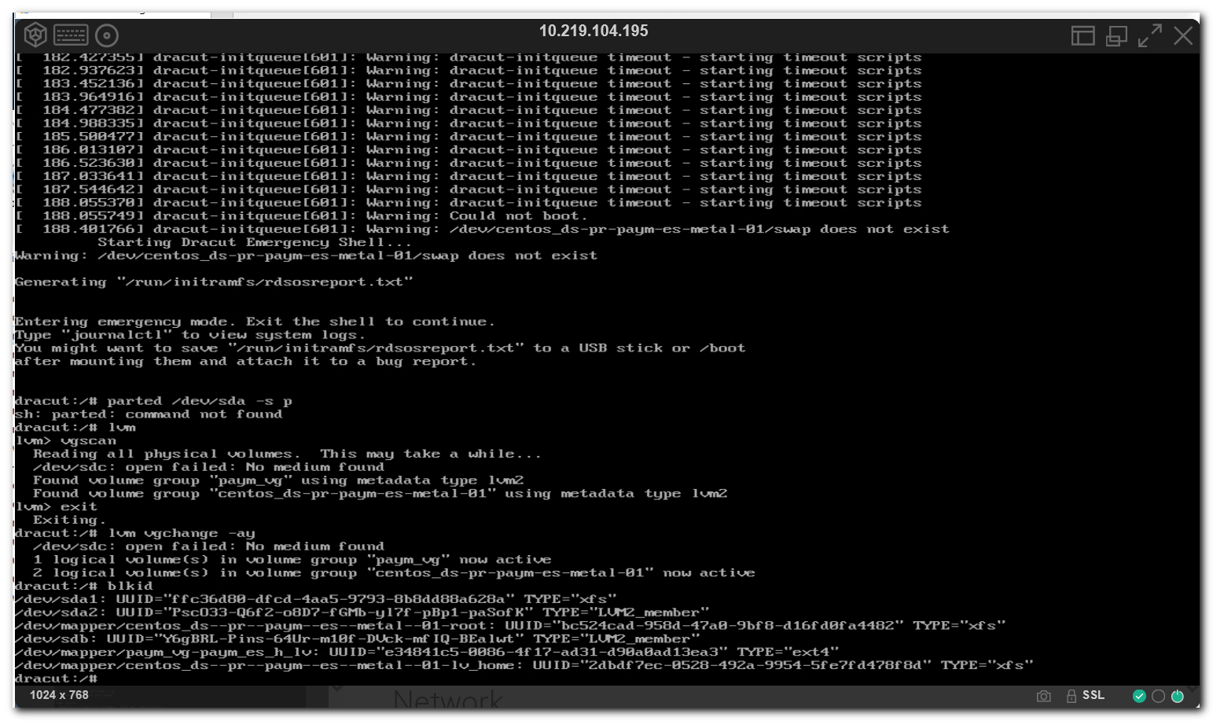

# But problem was not linked with root partition.
# I need only mount /boot partition and remove this parameter "rd.lvm.lv=centos_ds-pr-paym-es-metal-01/swap" from boot section in /boot/grub2/grub.cfg file.

# To did that I found previously saved information from /etc/fstab - UUID of boot partition.
# And then I saw in blkid output which device has that UUID. And mount it.
mkdir -p /mnt/boot
blkid
mount /dev/sda1 /mnt/boot
vi /mnt/boot/grub2/grub.cfg
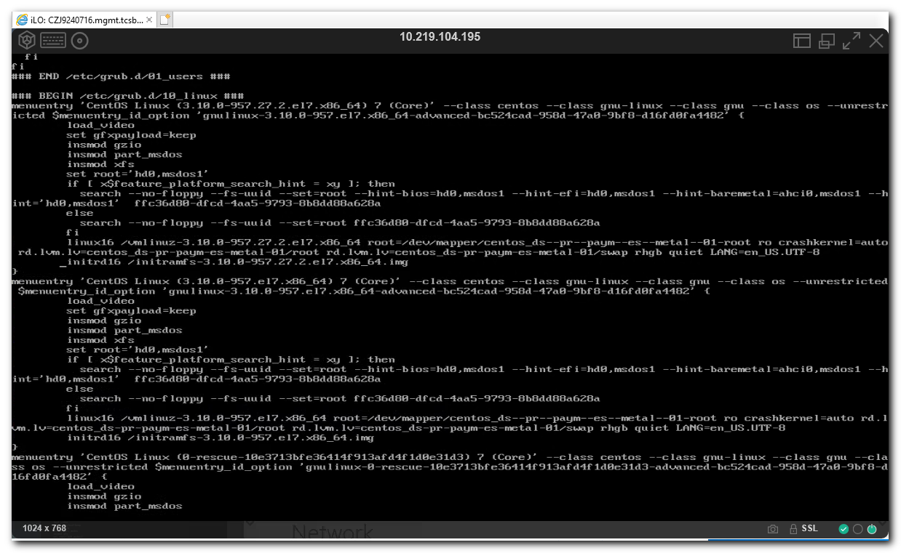
# Then I saved my edition of grub.cfg file. Unmouted /boot partition and rebooted server.

# Thise command was executed after server successfully booted.
#
root@ds-pr-paym-es-metal-01 ~$ sed '87,107!d' /boot/grub2/grub.cfg
### BEGIN /etc/grub.d/10_linux ###
menuentry 'CentOS Linux (3.10.0-957.27.2.el7.x86_64) 7 (Core)' --class centos --class gnu-linux --class gnu --class os --unrestricted $menuentry_id_option 'gnulinux-3.10.0-957.el7.x86_64-advanced-bc524cad-958d-47a0-9bf8-d16fd0fa4482' {
load_video
set gfxpayload=keep
insmod gzio
insmod part_msdos
insmod xfs
set root='hd0,msdos1'
if [ x$feature_platform_search_hint = xy ]; then
search --no-floppy --fs-uuid --set=root --hint-bios=hd0,msdos1 --hint-efi=hd0,msdos1 --hint-baremetal=ahci0,msdos1 --hint='hd0,msdos1' ffc36d80-dfcd-4aa5-9793-8b8dd88a628a
else
search --no-floppy --fs-uuid --set=root ffc36d80-dfcd-4aa5-9793-8b8dd88a628a
fi
linux16 /vmlinuz-3.10.0-957.27.2.el7.x86_64 root=/dev/mapper/centos_ds--pr--paym--es--metal--01-root ro crashkernel=auto rd.lvm.lv=centos_ds-pr-paym-es-metal-01/root rhgb quiet LANG=en_US.UTF-8
initrd16 /initramfs-3.10.0-957.27.2.el7.x86_64.img
}

#
# linux16 /vmlinuz-3.10.0-957.27.2.el7.x86_64 root=/dev/mapper/centos_ds--pr--paym--es--metal--01-root ro crashkernel=auto rd.lvm.lv=centos_ds-pr-paym-es-metal-01/root rd.lvm.lv=centos_ds-pr-paym-es-metal-01/swap rhgb quiet LANG=en_US.UTF-8
#

root@ds-pr-paym-es-metal-01 ~$

root@ds-pr-paym-es-metal-01 ~$ parted /dev/sda -s p
Model: HPE LOGICAL VOLUME (scsi)
Disk /dev/sda: 300GB
Sector size (logical/physical): 512B/512B
Partition Table: msdos
Disk Flags:

Number Start End Size Type File system Flags
1 1049kB 1075MB 1074MB primary xfs boot
2 1075MB 300GB 299GB primary lvm

root@ds-pr-paym-es-metal-01 ~$ pvs
/dev/sdc: open failed: No medium found
PV VG Fmt Attr PSize PFree
/dev/sda2 centos_ds-pr-paym-es-metal-01 lvm2 a-- 278.36g 213.36g
/dev/sdb paym_vg lvm2 a-- <5.24t 1.64t
root@ds-pr-paym-es-metal-01 ~$ vgs
VG #PV #LV #SN Attr VSize VFree
centos_ds-pr-paym-es-metal-01 1 2 0 wz--n- 278.36g 213.36g
paym_vg 1 1 0 wz--n- <5.24t 1.64t
root@ds-pr-paym-es-metal-01 ~$ lvs
LV VG Attr LSize Pool Origin Data% Meta% Move Log Cpy%Sync Convert
lv_home centos_ds-pr-paym-es-metal-01 -wi-ao---- 15.00g root centos_ds-pr-paym-es-metal-01 -wi-ao---- 50.00g
paym_es_h_lv paym_vg -wi-ao---- <3.60t
root@ds-pr-paym-es-metal-01 ~$

# This server has no swap.
root@ds-pr-paym-es-metal-01 ~$ swapon

root@ds-pr-paym-es-metal-01 ~$ lsblk
NAME MAJ:MIN RM SIZE RO TYPE MOUNTPOINT
sda 8:0 0 279.4G 0 disk
├─sda1 8:1 0 1G 0 part /boot
└─sda2 8:2 0 278.4G 0 part
├─centos_ds--pr--paym--es--metal--01-root 253:0 0 50G 0 lvm /
└─centos_ds--pr--paym--es--metal--01-lv_home 253:1 0 15G 0 lvm /home
sdb 8:16 0 5.2T 0 disk
└─paym_vg-paym_es_h_lv 253:2 0 3.6T 0 lvm /mnt/hot_01
root@ds-pr-paym-es-metal-01 ~$

#
# Before I understood how to fix difficulties, I did follow things.
# I mounted /root partition, created swap-file, then unmount /root partition and run xfs_repair for it.
# I used follow commnads, but they were useless because there were not /dev/... devices under chroot environment.
mkdir -p /mnt/root
mount /dev/mapper/centos_ds-pr-paym-es-metal-01-root /mnt/root
chroot /mnt/root

# I found a way how to create swap file, but it was not helped me, so it was deleted by me after the server booted correctly.
/mnt/root/sbin/dd if=/dev/zero of=/mnt/root/swapfile bs=1M count=2048

# Next my idea was to change mount option in /etc/fstab, where set option to run filesystemc check after lot time it used.
# But in /etc/fstab was "0 0" options at the end of all lines.

...
exit

umount /mnt/root

# There was not found errors on /root partition.
# I'm not sure - was it in /bin or it was not, but xfs utilities exist under dracut - that's the fact.
/bin/xfs_repair /dev/mapper/centos_ds-pr-paym-es-metal-01-root

20140828 #354104 Hard drive failure on ds-gp-prod-sdw6.docx - here I found my notes about xfs_repair utility.
mkswap,swapon,swapoff - here I wrote how create swapfile.

